

DRAFT TERMS OF REFERENCE

Consultancy for Provision of Technical Advisory Services to the Zambezi River Authority, ZESCO Limited and ZESA Holdings for the Development of the Batoka Gorge Hydro Electric Scheme (BGHES)

- Introduction
The Zambezi River Authority (the Authority) is a bilateral organization owned by the Republics of Zambia and Zimbabwe and mandated to operate, monitor and maintain the Kariba Dam Complex as well as exploit the full potential of the shared portion of the Zambezi River, located along the common border between the two countries.

The Authority would like to develop the 2,400MW Batoka Gorge Hydro Electric Scheme (“BGHES” or “Project”) located on the Zambezi River, approximately 47 Kilometres downstream of the Victoria Falls.
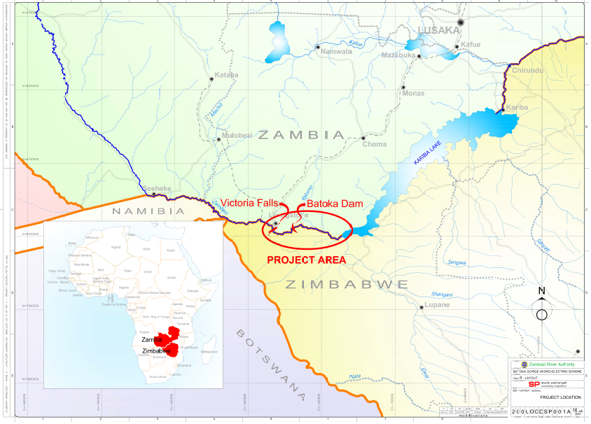
Fig 1: BGHES location

- Implementation Arrangements
The implementation arrangements comprise;
- The Authority
The Authority is the Implementing agency for the project on behalf of the Republics of Zambia and Zimbabwe, “the Contracting States”.
- The two National Utilities the Republics of Zambia and Zimbabwe.
  - ZESCO Ltd
ZESCO Limited is the national utility in Zambia.
  - ZESA Holdings
ZESA Holdings is the national utility in Zimbabwe with the following subsidiaries; Zimbabwe Power Company (ZPC), Zimbabwe Electricity Transmission and Distribution Company (ZETDC), ZESA Enterprises and PowerTel Communications ltd.
The national utilities are key partners in the implementation of the project
- The Legal and Financial Transaction Advisor (LFTA).
The Legal and Financial Transaction Advisor (LFTA) is Pricewaterhouse Coopers (PwC) in Association with Corpus Legal Practitioners, Energy Systems Planning (Pvt) Ltd, Atherstone & Cook.
- The Developer
A Consortium of Power Construction Corporation of China Ltd and General Electric Power China Construction Limited and General Electric was appointed as the Developer under the Build, Operate and Transfer Mode. The Developer shall form a Special Purpose Vehicle to manage the Project.
- The Technical Advisor
Under this the implementation arrangements, the Authority, together with ZESCO Ltd and ZESA Holdings, are desirous of contracting a Technical Advisor (TA) to provide technical support before and during Construction including Defects Liability Period (DLP) of the BGHES and in this regard, the three institutions shall constitute the Contracting Party in relation to the TA Consultancy contract.
- Project Scope
Based on the latest engineering studies, the proposed key works to be constructed for the Project include:
- 175m high, 720m long rolled compacted concrete gravity arch dam;
- Radial gated crest type spillway;
- Two surface power plants, one on either side of the river bank, each having a capacity of 1,200MW, with a combined capacity of 2,400MW;
- 6 x 200MW Francis turbines in each powerhouse;
- Four intakes in the reservoir which will take the water through 4 tunnels (each approximately 0.5km in length) to the two surface power plants downstream of the dam;
- Diversion tunnels
- Switchyards for both power plants
- Transmission lines connecting the Project to the grid in Zambia and in Zimbabwe:
  - BGHES to Mukuni substation (2 x 330kV x 22km,) in Zambia;
  - BGHES to Muzuma in Choma (1 x 330kV x 151km) in Zambia;
  - Muzuma to Nambala substation (1x 330kV, 230km) in Zambia
  - Batoka North and Batoka South Interconnector (2 x 330kV)
  - BGHES to Hwange (2 x 400kV x 70km) in Zimbabwe; and
  - BGHES to Chakari (2 x 400kV x 400km) in Zimbabwe.
The above Transmission scope may change depending on the outcome of the network studies to be undertaken by the Developer.
- Construction of access roads on both sides of the two contracting countries (approx. 90Km);
- Construction of the operational staff townships and office complex for the Authority and the Power utilities on both sides of the river banks with social amenities
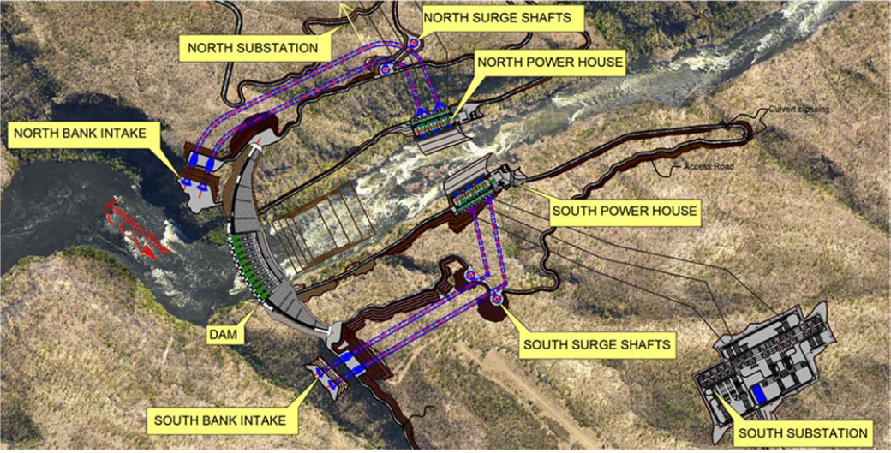
Figure 2: BGHES project features

- Project Status
The Consortium of Power Construction Corporation of China and General Electric was awarded the contract to develop the Project under the Build, Operate and Transfer Basis. Negotiations are underway and expected to be completed by November 2019 while construction commencement is foreseen to be in August 2020.

The preparatory studies have also reached advanced stages with the draft feasibility reports having been submitted by the Consultants undertaking the studies. Final reports are expected by end of September 2019.

- Project Structure
The Project structure is still under consideration between the Contracting Party and the Developer. However, preliminary indications are that a Special Purpose Vehicle (SPV) Company will be established to coordinate the development of the project. Subsidiary SPVs may be established in both Zambia and Zimbabwe to oversee Country specific developments. The Authority and the Utilities may have equity participation in the SPV. The Integrated public/private dam & power plants will be delivered under an Engineering, Procurement and Construction (EPC) contract procured by the SPV. The SPV may elect to appoint an Owners Engineer to manage the Project.

- Objectives of the Consultancy Contract
To provide Technical Advisory services to the Contracting Party before and during project Construction, to successfully deliver the BGHES Project; with services covering the entire project spectrum from Contract negotiations through to the Commercial Operation Date (COD) for the Project.

- Scope of the consultancy
The Consultant will be expected to undertake the following:
- Assist with the contract negotiations with the developer: The Consultant will be expected to participate in all contract negotiations with the developer and offer Technical advice to the Contracting Party until Financial close;
- Technical Advisory services during project Construction: The Consultant shall offer Technical Advice to the Contracting Party with respect to the Civil, Hydro-Mechanical, Electro-Mechanical and Transmission and Distribution Infrastructure works during construction and follow-up of the Contracting Party’s staff training by the Developer.

- Detailed Scope of the consultancy
Main tasks for the Consultant:

Task 1 – Review of previous studies and project documentation
Prior to the start of the execution of services, the Consultant will review existing studies and documentation related with the BHES such as:
- Feasibility Study;
- Environmental and Social Impact Assessment (ESIA);
- Environmental and Social Management Plans
- Resettlement Action Plan (RAP)
- Tender Documents; and
- Transaction Advisory Report.
- Draft Project Agreements

The Consultant will use this review to be familiar with all the technical features of the Project as well as the expected implementation framework,

Task 2 – Assistance during contract Negotiations with the developer
- Attend the contract negotiations with the Developer. The negotiation meetings will be held in the following indicative countries:
  - Zambia
  - Zimbabwe
  - China
  - United States of America
For the purposes of evaluation, the Consultants shall provide unit rates for all staff and also reimbursable costs associated with contract negotiations logistics. A total number of 10 separate negotiation meetings with average duration of 7 days each including travel will be assumed with 3 experts attending for each.
- Attend all due diligence visits to developer’s project sites. These are likely to be in China, Africa and Europe. A total number of 4 separate visits with a average duration of 7 days including travel shall be assumed. It is further assumed that the TA will have 3 experts attending each meeting.
- Review all technical proposals by the Developer and advise the Contracting Party accordingly
- Advise the Contracting Party on all technical issues on the project;

Task 3– Technical support during Construction phase
Under this task, the Consultant will carry out the following activities but not limited to:
- Assist and advise the Client in the overall management and contract administration,
- Undertake technical reviews for all proposals by the Developer
- Identify and recommend required capacity building by the Contracting Party at different project phases
- Carry out planned and impromptu safety and quality checks and audits in accordance with quality assurance and safety standard adopted by the project.
- Identify and advise the Contracting Party on project risks
- Witness all required performance tests for the scheme,
- Attend monthly meetings with the Developer

- Duration of the Assignment
The Technical Advisor will be engaged up to the end of the Defects Liability Period (DLP). Preliminary indications are that Construction period will take about 6 years. This however may change once the Developer has prepared a detailed work schedule. The DLP of 24 months has been assumed.
- Contract type
The TA will be engaged on a time-based type of Contract for the whole duration. The TA will be expected to undertake monthly visits during the Construction phase and will be expected to produce quarterly reports to the client. All travel costs and stationary costs will be borne by the Technical Advisor.

- Reporting and Communication
All correspondences shall be addressed to the Chief Executive, Zambezi River Authority.
The Consultant will be required to submit reports. All reports will be written in concise, clear and well-edited Standard English. Where need arises, the client may require the consultant to engage the services of an editor of which the costs shall be borne by the consultant.

Table 1: Deliverables
Report | Draft submission
Inception report | One month after commencement of services
Monthly reports | By the end of the first week of the next month
Quarterly Progress Reports | Within two weeks following end of each quarter of the assignment.
Annual reports | By the end of the first month of the following year
Site and project meetings | As required
Commissioning report | Three months after commissioning
Final Report | Draft to be issued one month before the end of the contract so that the agreed final version can be issued at the end of the contract. The Final Report represents the basis for the final payment.

Submission & approval of progress reports
The copies of the activity progress reports referred to above must be submitted to the client. The client is responsible for formally approving the progress reports, after consultations with other stakeholders.

- Obligations of the client
  - Data, Reports and Liaison
The client will ASSIST with the following data and reports WHERE AVAILABLE:
- Provide available copies of previous Feasibility study reports, current feasibility study reports and other relevant documents;
- The Client will provide liaison to ensure that the Consultant has access to all available information required for timely execution of the assignment.
- Facilitate consultation with relevant stakeholders (Ministries / Departments, key stakeholders and communities);
  - Immigration and Residence Permits
The Client will provide the Consultant assistance required to obtain necessary immigration and residence work permits for the approved expatriate personnel and their dependents. However, the responsibility remains that of the Consultant.
- Obligations of the Consultant
  - Personnel
    - The Consultant will mobilize a coherent, dynamic and organized professional team of experts with experience in similar assignments to undertake this assignment. The Consultant shall provide experts with the required qualifications and experience for the activities in the scope of services.
    - The Consultant shall co-operate and liaise with the Client, stakeholders and with the affected local authorities.
    - The Consultant shall exercise all due skills, care and diligence in the performance of the services and will carry out all responsibilities in accordance with internationally recognised professional standards.
    - The Consultant will take into account relevant comments from the Client, all relevant Government Authorities and other agencies and shall be responsible for the accuracy of all data collected, analysis, conclusions and recommendations.
    - Adequate staff shall be provided to complete the assignment within the agreed time frame.
    - The remuneration of the Consultant by the Client, in accordance with the contract agreement, will constitute only payment for the services rendered, and neither the Consultant, nor its employees, shall accept commissions, discount, allowance or indirect payment or other consideration with or in relation to the agreement or to the discharge of his obligation herein. In this connection, the Consultant shall not have the benefit, whether directly or indirectly, of any gratuity or commission in respect of any patented article or protected article or process used on or for the purpose of the agreement unless it is mutually agreed upon in writing that he may.
    - The copyright of all documents prepared by the Consultant in connection with the agreement will automatically be transferred to the Client. The Consultant may make copies of such documents but shall not use the contents thereof for any purpose unrelated to the services without prior written approval of the Client;
    - Equipment and material furnished to the Consultant by the Client or purchased by the Consultant with funds wholly supplied or reimbursed by the Client shall be the property of the Client and shall be so marked. Upon completion or termination of the services, the Consultant shall furnish to the Client inventories of the equipment and materials referred to above;

- Consultants Qualifications and Required Expertise of Consultant’s Key Personnel
The Consultant Firm should demonstrate capability in providing Technical Advisory services for large dam infrastructure and hydropower plants of similar nature and complexity as the BGHES having carried out similar work on at least 2 similar assignments specific to Public Private Partnership, Independent Power Producer or Build, Operate and Transfer Projects in the energy sector with minimum installed capacity of 500MW in the last twenty (20) years. This may include ongoing activities. The consultant’s key staff should include a team of international experts with extensive experience from similar projects and in the field of design, construction supervision, quality assurance and contract/project management of large hydropower projects.
The members of the team will have the skills and experience necessary to undertake the range of tasks set out in these terms of reference. Each individual on the team must be personally available to do the work as and when required. All proposed staff shall submit signed CVs. The key personnel should come from the following fields of expertise:

  - Project Manager: As the team leader, He/she shall be the principal contact person between the Consultant and the Client. The Project Manager shall be a Registered or Chartered Civil Engineer, with a Masters Degree in Engineering. He/she must have at least Fifteen (15) years of cumulative experience related to hydropower construction management. The Project Manager must have had, in the last ten (10) years, specific experience in managing consultancy teams working on feasibility studies, detailed engineering design for hydropower structures, and construction management. The Team Leader shall prove to have been involved in two (2) hydropower projects of similar size and complexity based in international contracts. In addition, the Team Leader shall be a person with good oral and written communication skills and shall demonstrate a high level of organizational skills during implementation. He/She must be fluent in English. The Team Leader will be full time for the duration of the project, except for normal annual leave.

  - Electro-Mechanical Engineer: The Electro-Mechanical Engineer will be responsible for all electro-mechanical components matters. He/She shall have a Masters Degree with a bias in electro-mechanical engineering, be a Registered or Chartered Engineer with at least Ten (10) years of relevant experience related to hydropower projects. He/she should have experience on at least 3 (three) similar projects. He/She shall be fluent in English.

  - Geologist/Hydro-geologist: The Geologist / Hydro-Geologist will undertake the geological and hydro-geological assessment of the dam site, reservoir area, power station sites as well as water/power tunnels as required. He/She must have a degree in geology and shall be a Registered or Chartered Geologist with at least Fifteen (15) years of cumulative geological experience with specific experience in two (2) hydropower projects. He/She shall be fluent in English.

  - Dam design specialist: The Dam Design Specialist shall be responsible for providing expert opinion on all aspects of the dam design. He/She shall be a Registered or Chartered Engineer, preferably with relevant Masters Degree. He/she must have at least twenty (20) years of cumulative experience relating specifically to dam engineering with at least Fifteen (15) years’ experience of Roller Compacted Gravity Arch Dams. He/She shall have held personal responsibility for the design of at least two (2) Roller Compacted Gravity Arch Dams or dam rehabilitation projects of comparable size to BGHES. He/She shall be fluent in English.

  - Geotechnical Engineer: The Geotechnical Engineer shall be responsible for all site investigation works as well as interpretation of the results. He/She shall also perform all aspects of geotechnical design pertaining to the BGHES. He/She shall be a Registered or Chartered Engineer, with a degree in geology. He/she must have at least twenty (20) years of geotechnical experience preferably with Ten (10) years of cumulative experience relating directly to geotechnical aspects of Hydropower development. As such is expected to prove to have been involved in at least 3 (three) projects of a similar nature based on international contracts. He/She must be fluent in English.

  - Structural Engineer: The Structural Engineer will be responsible for reviewing the design of all concrete and structural steelwork elements of the scheme. He/She shall be a Registered or Chartered Civil or Structural Engineer with a Degree and at least Fifteen (15) years of relevant experience relating to hydropower structures, dams and water retaining structure design . As such, he/she is expected to prove to have been involved in at least 3 (three) projects of a similar nature based on international contracts. He/she shall be fluent in English.

  - Roads Engineer: The Roads Engineer will be responsible for the design review of the temporary or permanent diversion or access roads for the scheme. He/She shall be a Registered or Chartered Engineer with a degree and at least fifteen (15) years of relevant experience, part of which should be in Southern Africa. As such, he/she is expected to prove to have been involved in at least five (5) projects of a similar nature. He/She shall be fluent in English.

  - Social Specialist: The Social Specialist shall be responsible for Implementation of the RAP and ESMPs. He/she shall hold a relevant Masters Degree with 15 years’ relevant experience in community development addressing resettlement issues and social impact assessment, including preparation of Resettlement Action Plans, and stakeholder consultation associated with new infrastructure projects. He/she must also have work experience in Southern Africa and be fully cognizant of the gender-related issues, including the application of World Bank OP 4.12. Experience in health impact assessment is required. As such, he/she is expected to prove to have been involved in at least three (3) projects of a similar nature. He/she must be fluent English, and any local Languages in Zambia/Zimbabwe.

  - Environmental Expert: shall be responsible for review of all safety health and environmental aspects for the BGHES
He/ she shall have a minimum of a master’s degree in Environmental Sciences and a minimum of fifteen (15) years of experience in monitoring environmental aspects of infrastructure projects and experience in implementation and monitoring of environmental management and monitoring plan, health and safety plans, waste management plans, etc. Previous international experience in implementation of hydropower projects of similar nature is required. As such, he/she is expected to prove to have been involved in at least three (3) projects of a similar nature.

  - Transmission and Substations Engineer: Shall be responsible for review of all transmission and substation works. He/She shall be a Registered or Chartered Engineer with a masters degree in electrical engineering and at least fifteen (15) years of relevant experience. As such, he/she is expected to prove to have been involved in at least three (3) projects of a similar nature.

  - Additional Expertise
The additional expertise that shall have smaller but essential inputs may include, but may not be limited to,
- Environmental Expert with experience on the application of EMA guidelines in Zimbabwe
- Environmental Expert with experience on the application of ZEMA guidelines in Zambia
- Safety, Health and Environmental Expert (SHE)
- Payment arrangements
The Construction Supervision phase shall be governed by time-based payments where consultants submit invoice backed by time sheets for payment of fees and reimbursable accompanying the quarterly program progress reports. For construction phase, payment will be based on time input and proven reimbursbles and subject to submission of acceptable deliverables.
- Facilities to be provided by the Consultant during the Contract
The Consultant will provide the following facilities for the duration of the services;
- Own residential accommodation for all staff, including counterpart staff, close to the Project site. Accommodation of staff shall be the responsibility of the Consultant and this shall be treated as reimbursable costs to be included in the financial proposal.
- All the necessary office space and new office furniture and equipment for his staff and for the counterpart staff.
- Transport - 03 nos.4WD vehicles for use by the Consultant and Counterpart Staff. Estimates of running and maintenance costs of vehicles for the duration of the contract should be included in the financial proposal. The vehicles shall be surrendered to the Client at the end of the Project at no cost.
- All the necessary equipment, tools, computer software and computer hardware for use by his staff and the counterpart staff.
- Software and hardware for project management e.g. Microsoft Project or Primavera.
- All the necessary telecommunications, telephones, internet, telefax and office consumables to his staff and the counterpart staff.

All of the office equipment, furniture, vehicles etc. referred to above shall be handed over to the Client at no cost after the completion of the Project.

