Devils Gorge Hydro-Electric Scheme (DGHES)
Terms of Reference (ToRs)
Technical Advisory Services for Pre- Feasibility Studies for the development of the Devils’ Gorge Hydro-Electric Scheme
- Background
The Zambezi River Authority (the Authority) is a bilateral organization owned by the Republics of Zambia and Zimbabwe and mandated to operate, monitor, and maintain the Kariba Dam Complex as well as develop the full hydro power potential of the shared portion of the Zambezi River, common to the two Contracting States.
The proposed Devils’ Gorge Hydro-electric Scheme (HES) is located at the tail end of Kariba Dam, just downstream of the Gwayi/Zambezi Rivers Confluence.
The Devils’ Gorge HES was conceived in 1972 out of a study instituted by the predecessor of Zambezi River Authority, Central African Power Corporation. The aim of the study was to identify possible power sources which the intergovernmental institution could develop to meet the power demands of Zambia and Zimbabwe. Its recommended scheme included a 181 m high concrete arch dam, 65m of which are below the water level of the river, two underground power stations on each side of the river with a total capacity of 1240 MW for the scheme. The normal retention level of EL 595 was selected creating a reservoir of 33 billion m³.
In 1992-93 a feasibility study was commissioned by the ZRA for the Batoka Gorge Hydroelectric Scheme Feasibility Studies during which the Devils’ Gorge Scheme was looked at in greater detail and reserved as one of the potential sites for future development.
In addition, the Authority engaged Tractebel France (TEF) to undertake a prefeasibility of the Devils’ Gorge Project. No Environmental impact assessments have been conducted to date. But the current scope foresees only screening of impacts.

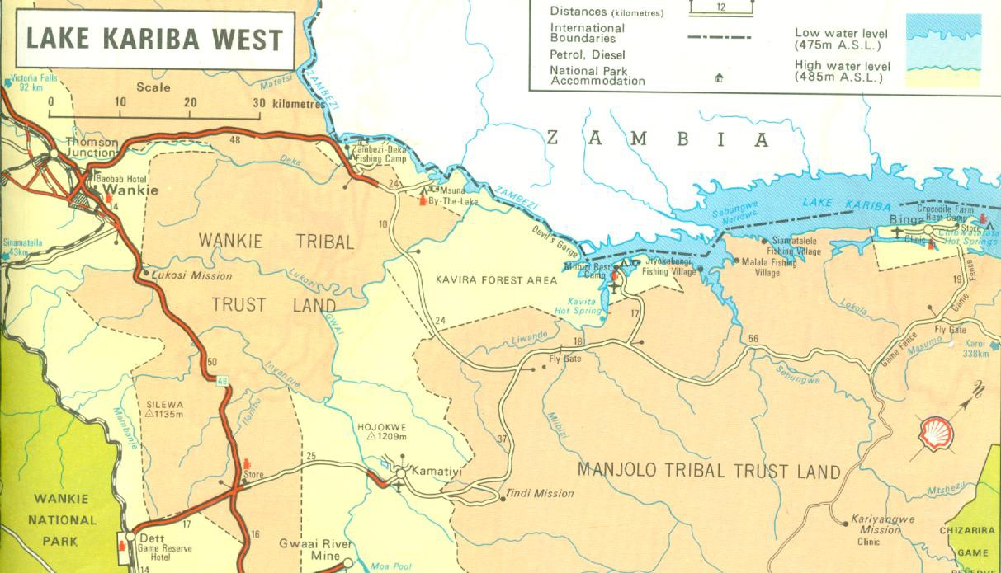
Fig 1: Location of Devils’ Gorge
- Consulting Services Required
ZRA, the ‘Client’ therefore seeks consulting services from a competent firm to undertake the role of Technical Advisor (TA) for the feasibility studies of the proposed DGHES. This will be a phased exercise, commencing with Phase 1 – Prefeasibility stage and Phase 2 – Detailed Feasibility stage. The Technical Advisor will review the outputs from the Prefeasibility consultancy and provide a second opinion and accordingly advise the client. In the execution of the services, the TA shall cooperate and liaise with ZRA, the Executing Agency (EA) of the project and the consultants tasked with conducting the feasibility studies, i.e., first the Prefeasibility and later the detailed Engineering Feasibility Studies (EFS). The Client will supervise and monitor the TA’s work, while the TA will be solely responsible for the accuracy of all findings and outputs, including conclusions and recommendations. The consultant will provide the expertise and manpower required to deliver the services on time, with care and due diligence.
- Objective
To provide Technical Advisory services in respect of the prefeasibility studies for the Devil’s Gorge.
  - Description of Services
The TA will review all available previous documentation on the Devils Gorge HES. The TA shall use this review to become familiar with all the technical features of the Project.
Additionally, the TA will review ALL work to be done during the prefeasibility and feasibility studies by the Consultants selected to conduct those specific works.
The TA to be procured shall NOT assume to be in a position to supervise the Feasibility Study consultants. However, it is expected that there will be close monitoring of the project without interfering with the works of the Feasibility Study consultants.
The technical advisory services will involve review and advisory services in relation to the pre-feasibility study consultancy which will entail undertaking pre-feasibility studies that would investigate and recommend amongst other EFS requirements, an optimal site, around the stretch between approximately 60km downstream of the proposed Batoka Gorge site and upstream of the area of influence of Lake Kariba as shown in figure 2 below. The initially recommended site shall also be analysed and compared with the other alternatives.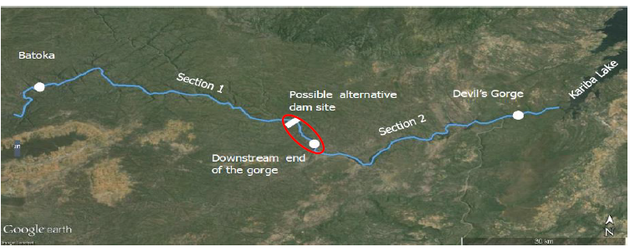Figure 2: Proposed alternative dam site. Screening required in the marked red area.
The TA will therefore review this alternative analysis and provide the Contracting Party with expert technical advice.
- Quality Assurance
The work will be reviewed by the Authority, National Utilities, and other Cooperating Partners working with the Authority. The reports will be deemed approved after ZRA clears them in writing.
- Scope of Work
The TA’s main tasks will include:
Task 1 – Review EFS work
- Review the work being done and submitted by the EFS Consultant and provide professional, expert opinion and advice. The TA may be requested by the Client to undertake a detailed review and analysis of some key findings and or recommendations from the feasibility study.
- Attend and participate in any workshops and meetings between the EFS Consultant and Client, where the TA’s presence is required, including, but not limited to:
  - Workshop where the options assessment report will be presented by the EFS to the Client and stakeholders for discussion chaired by the client.
  - Information transfer workshops chaired by the EFS Consultant.
- Review all technical proposals by the EFS Consultant and advise the Contracting Party accordingly.
- Advise the Contracting Party on all technical risks and issues on the project at feasibility stage of the project.

- Reporting and Communication Requirements
All correspondences shall be addressed to the Chief Executive. However, for day-to-day engagements, the contact person shall be the Senior Manager-Projects.
Reports will be written in concise, clear and well-edited Standard English. Where need arises, the client may require the TA to engage the services of an editor of which the costs shall be borne by the TA consultant. The expected deliverables are as detailed below:
Report | Summary | Draft Submission
Inception Report | Two weeks after commencement of services, the TA shall submit an Inception Report. The Report shall detail the preliminary views, approach, and work plan to be taken by the TA’s team. It shall summarize the methodology to be used, and the organization (logic diagram). | The Inception Report shall be submitted to the Client 2 weeks after commencement of contract.
Monthly Progress Reports | The TA shall prepare Monthly progress reports, which shall discuss activities undertaken during the period and progress against the program, issues and constraints that could affect the delivery of services and outputs and a program of work to be undertaken during the next period. The monthly progress reports shall be kept as brief as possible and shall be limited to highlighting progress, key issues and constraints encountered during the reporting period.  This will mostly be based on the EFS Consultant’s MPR. | By the end of the second week of the next month.
Options Assessment Report | The report shall indicate the TA’s review and professional interpretation and advice of the EFS Consultant’s site options considered, using the pre-agreed criteria and highlight the two recommended options for consideration by the Authority. | To be prepared and submitted 1 week from the date of submission of Options Assessment Report by the EFS Consultant
TA’s review report of Draft Engineering feasibility report | The TA will review the draft Engineering Feasibility report in its entirety and give its professional opinion to the Client. | To be submitted within 3 weeks of the date of submission of Draft Engineering Feasibility report by the EFS Consultant
TA’s review report of Draft ESIA screening report | The TA will review the draft ESIA screening report. The ESIA report may not require approval by Environmental Regulators ZEMA/EMA but simply to aide decision making implying the TA should ensure that the reports must be adequate and acceptable to the client, meeting all standard requirements. | Shall be delivered within 2 weeks of the date of submission of Draft ESIA screening report by the EFS Consultant.
TA’s review report of Final Reports | The TA shall conduct an overall review of the final Engineering Feasibility Report. | Will be prepared and submitted within 2 weeks of submission of Final EFS report by the EFS Consultant.

- Duration of the assignment
The consultant shall perform the tasks above within a period of forty weeks, net of the review period which will range from 2 weeks to one month for phase 1 (pre-feasibility stage) and depending on timeframe set for phase 2 (detailed feasibility stage), a contract extension will be discussed.
- Obligations of the Authority
The Client will provide the following inputs and facilities:
  - Documents
Where available, such as:
- 1972 Gibb, Merz and McLellan Report
- 1993 documentation following the Batoka Gorge Hydro Electric Scheme, Feasibility Study
- 2007 SAPP Regional Generation and Transmission Expansion Plan Study
- 2007 IWRM Strategy for Zambezi River Basin
- 2010 Multi-Sectoral Investment Opportunity Analysis
- Power Master Plans in Zimbabwe and Zambia
- Tractebel Engineering Analysis of the Devils Gorge Project 2016 Report
  - Administrative Assistance
Render all possible assistance to the Consultant in the obtaining of the following for the Consultant's staff:
  - working permits,
  - residence visas,
  - exit, re-entry and exit visas,
  - other licensing documents, etc.
Provide assistance in facilitating and expediting customs procedures in connection with importation of equipment and materials necessary for the consultant's services and for the personal use of the consultant's staff.
- Obligations of the Consultant
- The Consultant will mobilize a coherent, dynamic and organized professional team of experts with experience in similar assignments to undertake this assignment. The Consultant shall provide experts with the required qualifications and experience for the activities in the scope of services.
- The Consultant is expected to be fully self-sufficient in all respects for undertaking the assignment including accommodation, office space, equipment and supplies, communication and transportation.
- The Consultant shall co-operate and liaise with the Client, and stakeholders as may be required.
- The Consultant shall exercise all due skills, care and diligence in the performance of the services and will carry out all responsibilities in accordance with internationally recognised professional standards.
- The Consultant will take into account relevant comments from the Client, all relevant Government Authorities and other agencies and shall be responsible for the accuracy of all data collected, analysis, conclusions and recommendations.
- Adequate staff shall be provided to complete the assignment within the agreed time frame.
- The copyright of all documents prepared by the Consultant in connection with the agreement will automatically be transferred to the Client. The Consultant may make copies of such documents but shall not use the contents thereof for any purpose unrelated to the services without prior written approval of the Client.
- Equipment and material furnished to the Consultant by the Client or purchased by the Consultant with funds wholly supplied or reimbursed by the Client shall be the property of the Client and shall be so marked. Upon completion or termination of the services, the Consultant shall furnish to the Client inventories of the equipment and materials referred to above.
- Contract Type
The TA will be engaged on a lumpsum contract.
- Consultants, Experience, Qualifications and Required Expertise of Consultant's Key Personnel
The firm and team selected to carry out this assignment should have the following minimum qualifications:
  - Firm Experience
- At least 10 years’ general experience in similar projects in hydropower.
- Specific experience: The consultant must have carried out at least 3 related assignments in the last 15 years.
- Ability to form and effectively manage multi-disciplinary teams in order to draw upon the experience of specialists as needed.
  - Key Experts
The approximate time effort for each Key staff will be proposed by the consultant. The consultant shall prepare the proposal based on a detailed work plan, staffing, and time inputs necessary to accomplish the scope of the Terms of Reference.
The consultant shall provide an appropriate mix of experts and specialists as required by the tasks in the Terms of reference. The consultant is responsible for optimization of his staff requirements after assessing the scope of work. Each of the Key Professional Personnel shall be a senior level professional with at least 10 years of experience in appropriate area of expertise and specific experience performing tasks similar to the task as assigned in the consultant’s proposed staffing plan and similar to this project. The following table shows the required Key Professional Personnel for the project.

NO. | Expert Position
1 | Team leader: The Team leader must possess a master’s degree in civil engineering/Hydropower Engineering or equivalent with at least 15 years relevant experience in undertaking Engineering feasibility studies for hydropower projects. He must have executed at least three similar projects in the past 10 years. He/she must be registered with a recognized Engineering Institution and be eligible for registration with the Engineering Institution of Zambia. He/she must have experience of working in Africa
2 | Power Economist: The Power Economist must possess a master’s degree in economics or related field with at least 10 years of experience in Hydro Power Generation Costs Estimation, Power Sector Economic Analysis. He must have executed at least two similar projects in the past 10 years. The Specialist should have experience in Africa Region.
3 | Electro-Mechanical Engineer: The Engineer must possess a master’s degree in mechanical/electrical engineering or equivalent with at least 15 years of relevant experience in preparing detailed hydropower designs and installation of electro-mechanical equipment. He/she must be registered with a recognized Engineering Institution. He/she must have executed at least three (3) projects of a similar nature. He/she must have experience of working in Africa
4 | Geologist/Hydrogeologist: The Geologist / Hydrogeologist will undertake the geological and hydro-geological assessment of the dam site, reservoir area, power station sites as well as water/power tunnels as required. He/she must have a degree in geology and shall be a Registered or Chartered Geologist with at least Fifteen (15) years of cumulative geological experience with specific experience in two (2) hydropower projects.
5 | Environmental Specialist: The Environmental specialist must possess a master’s degree in environmental management with at least 10 years of experience in environmental impact assessments of similar projects. He/she must have executed at least three (3) projects of a similar nature. The Specialist should have experience in Zambia/Zimbabwe
6 | Social Specialist: The Social Specialist shall hold a relevant Social Science master’s degree, with 10 years' relevant experience in community development addressing social impact assessment, and stakeholder consultation associated with new infrastructure projects. He/she must also have work experience in Africa, including the application of World Bank OP 4.12. He/she must have executed at least three (3) projects of a similar nature (The experience should be in Dams or hydropower projects and other projects too). He/she must be fluent English, and any local Languages in Zambia/Zimbabwe.

The consultant can propose additional non key experts to enable him carry out the scope as per the Terms of reference.
- Submission & approval of progress reports
The copies of the activity progress reports referred to above must be submitted to the client. The client is responsible for formally approving the progress reports, after consultations with other stakeholders.
- Payment arrangements
Phase 1 shall be governed by lumpsum payments after approval of each deliverable.

- Facilities to be provided by the Consultant during the Contract
The Consultant will provide the following facilities for the duration of the services:
- All the necessary office space and office furniture and equipment for his staff and for the counterpart staff.
- All the necessary equipment, tools, computer software and computer hardware for use by his/her staff and the counterpart staff.
- Software and hardware for project management e.g., Microsoft Project or Primavera.
- All the necessary telecommunications, telephones, internet, telefax and office consumables to his staff and the counterpart staff.

